Report Safeguarding Concerns
‘Never do nothing’
It is every adult’s responsibility to safeguard children and adults at risk.

If you are not a Club Safeguarding Officer (CSO) and you do not feel comfortable reporting this concern to a CSO you must contact the Motorsport UK Compliance Officer via the details at the bottom of this document.

Threats of immediate harm or danger should be reported to the police and/or Children’s Services or the Local Authority Designated Officer AND the Compliance Officer at Motorsport UK. If you are not sure what to do, please call the mobile number at the bottom of this document.
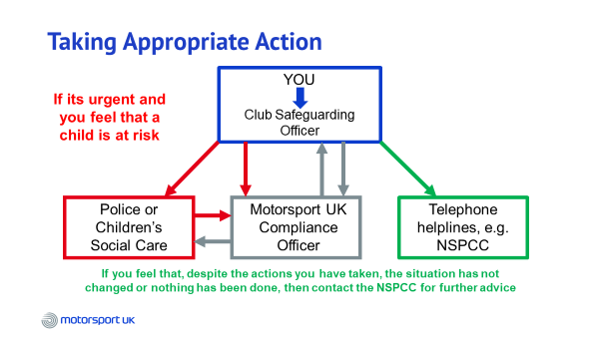

Motorsport UK Compliance Officer:
T: +44 (0) 1753 765071
M: +44 (0) 7519 801674
E:Safeguarding@motorsportuk.org

